Open node js command promt-> run as admin

C:\Windows\System32>npm install -g @angular/cli@8 🡺 to use ng ommand

To check version

ng version

Angular cli complete project structure to build/test/build element

Create folder for workspace

Ng new <project name>

Routing Y

CSS selected Click Enter

.npmrc settitngs:

Npm config set strict-ssl=false

Refer file

Visio code

Open folder

Select folder name

Project loaded

Package.json overview

Open command proj folder

Cd project

Type ng start

C:\Users\febboa2020>cd ecommerce

C:\Users\febboa2020\ecommerce>npm start

Ng serve

Ctrl c y

Ng serve -–host 0.0.0.0 –-port 0 => check the ports available

Change the port number in package.json

Ng: “ng serve –port 7070 –open --watch” watch is for library loading

C:\Users\febboa2020\ecommerce>ng serve --host 0.0.0.0 --port 0

WARNING: This is a simple server for use in testing or debugging Angular applications

locally. It hasn't been reviewed for security issues.

Binding this server to an open connection can result in compromising your application or

computer. Using a different host than the one passed to the "--host" flag might result in

websocket connection issues. You might need to use "--disableHostCheck" if that's the

case.

10% building 3/3 modules 0 activei ｢wds｣: Project is running at http://0.0.0.0:63102/webpack-dev-server/

i ｢wds｣: webpack output is served from /

i ｢wds｣: 404s will fallback to //index.html

chunk {main} main.js, main.js.map (main) 49.4 kB [initial] [rendered]

chunk {polyfills} polyfills.js, polyfills.js.map (polyfills) 268 kB [initial] [rendered]

chunk {runtime} runtime.js, runtime.js.map (runtime) 6.15 kB [entry] [rendered]

chunk {styles} styles.js, styles.js.map (styles) 9.71 kB [initial] [rendered]

chunk {vendor} vendor.js, vendor.js.map (vendor) 4.08 MB [initial] [rendered]

Date: 2020-02-10T09:13:49.458Z - Hash: f19e9253740f640b2016 - Time: 6816ms

** Angular Live Development Server is listening on 0.0.0.0:63102, open your browser on http://localhost:63102/ **

i ｢wdm｣: Compiled successfully.

npm run build

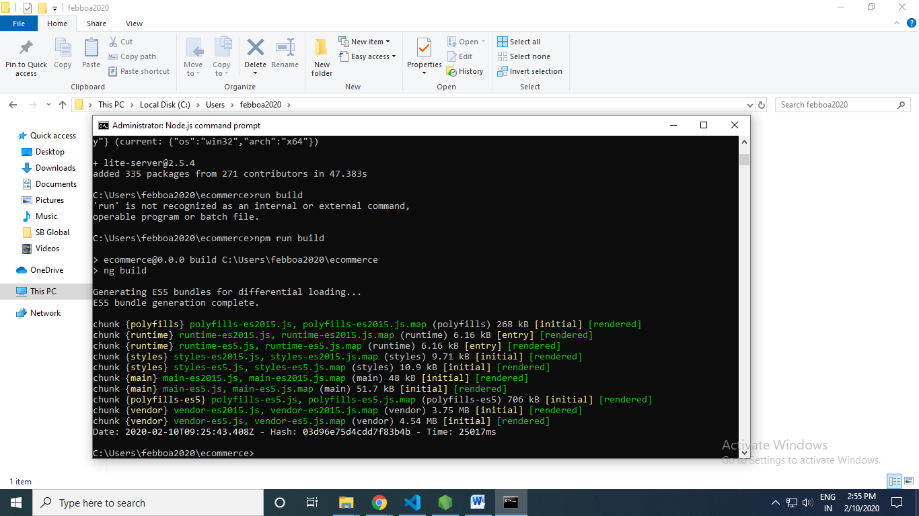

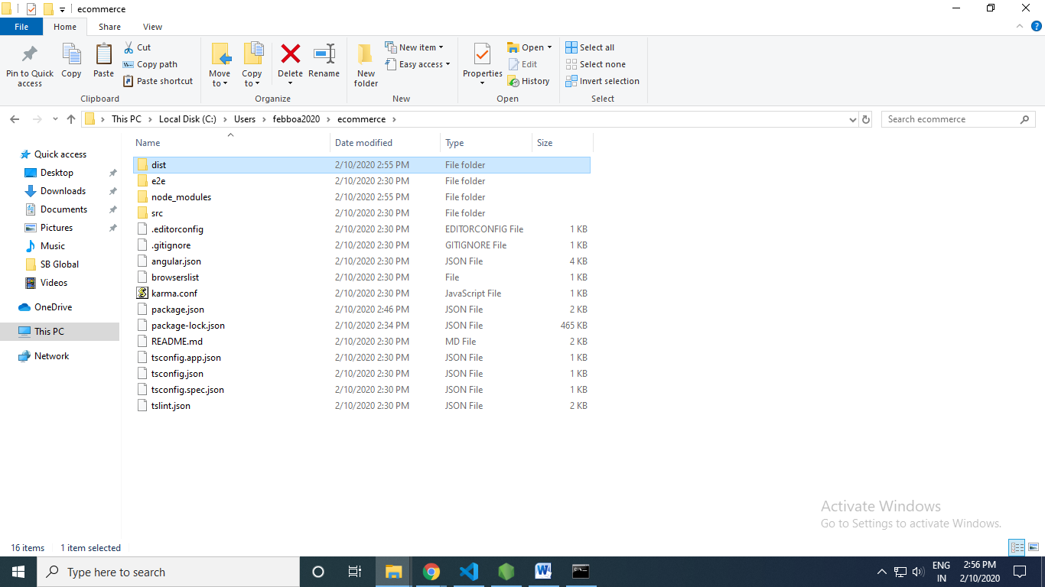

Copy dist folder in desktop

Npm install –g lite-server

Dist> lite-server -baseDir=./ecommerce

npm install @angular/material@8.2.3

npm install nightwatch

**tsconfig.js**

mapping file -> mapping file-> ts js mapping

C:\Users\febboa2020\ecommerce>npm install nightwatch –dev

To add in dev dependencies

Polyfills.js

C:\Users\user\Desktop\dist>lite-server --baseDir=./ecommerce

uncomment the import classlist.js

npm install –save classlist.js

Order of exeecuton

Packjae.json

Angular.json-> Build I shappening

Tsconfig app.json -> setting is retieved

Tsconfig.ts ->

Finally index.html

Main.ts -> PLatformBroswerdynamci

* Offering the caching
* Version declaration
* Compiler use
* Resource loadin
* Allteh setting available

Bootstra module-> start up module

Call oes to app Module-> Metadata

Declaration

Import

Saty up component

BroserModule->

App Routing -> pge navigation

App.componebnt.html

Welcome page

Restart

Ctrl c

Npm start

Ng serve –port 77070n –open –watch

Polyfills -> what sfiles require when brower is changes

Bowser specific

Not always required

Sourcempa -> debugging purpose we need it

Ng g c header

Ng g c footer

Npm install priming –save

<https://github.com/eswaribala/rps_angular_chn_2020.git>

Create servic

